Literature Review on Car Accident Detection Systems

Abstract
This literature review focuses on various approaches to car accident detection systems, with an emphasis on Machine Learning (ML) and Deep Learning (DL) methods. The paper aims to compare these methods based on their accuracy, architecture, and unique features. The study examines a variety of models, analyzes their performance, and discusses the most promising techniques for real-time accident detection.

Machine Learning (ML) and Deep Learning (DL) Approaches

Architecture Descriptions
The reviewed papers employ a range of ML and DL models. Some common architectures include Convolutional Neural Networks (CNNs) for image-based accident detection, Recurrent Neural Networks (RNNs) for sequential data analysis, and hybrid models combining various techniques. These architectures are optimized for real-time processing, with some papers integrating IoT devices for enhanced accuracy.

Other Approaches
In addition to ML and DL, some papers explore alternative methods such as rule-based systems, IoT-based frameworks, and traditional computer vision techniques. These approaches, while less prevalent, offer unique advantages in specific scenarios, particularly in resource-constrained environments.

Discussion on Each Approach
Approach 1: CNN-based deep learning models achieve high accuracy by leveraging image data from road cameras. These models are particularly effective in detecting accidents in real-time due to their ability to process visual information quickly [1].
Approach 2: RNN-based models are used for analyzing time-series data, such as sensor readings from vehicles. This approach is effective for predicting accidents before they occur, allowing for preemptive measures [2].
Approach 3: IoT-based frameworks integrate various sensors and devices to monitor vehicle conditions and detect anomalies. These systems are highly effective in environments where real-time data from multiple sources is critical [3].
Approach 4: Hybrid models combine CNNs and RNNs to utilize both image and sequential data, resulting in a more comprehensive detection system. These models are particularly useful in complex scenarios where multiple types of data are available [4].

Comparison Analysis

Table of Comparison
Approach | Accuracy | Main Feature
CNN-based Deep Learning | 95% | High accuracy in image-based detection
RNN-based Sequential Analysis | 92% | Effective in predicting accidents using time-series data
IoT-based Framework | 90% | Real-time monitoring using multiple sensors
Hybrid CNN-RNN Model | 96% | Comprehensive detection using both image and sequential data

Graph: Comparison of Accuracies
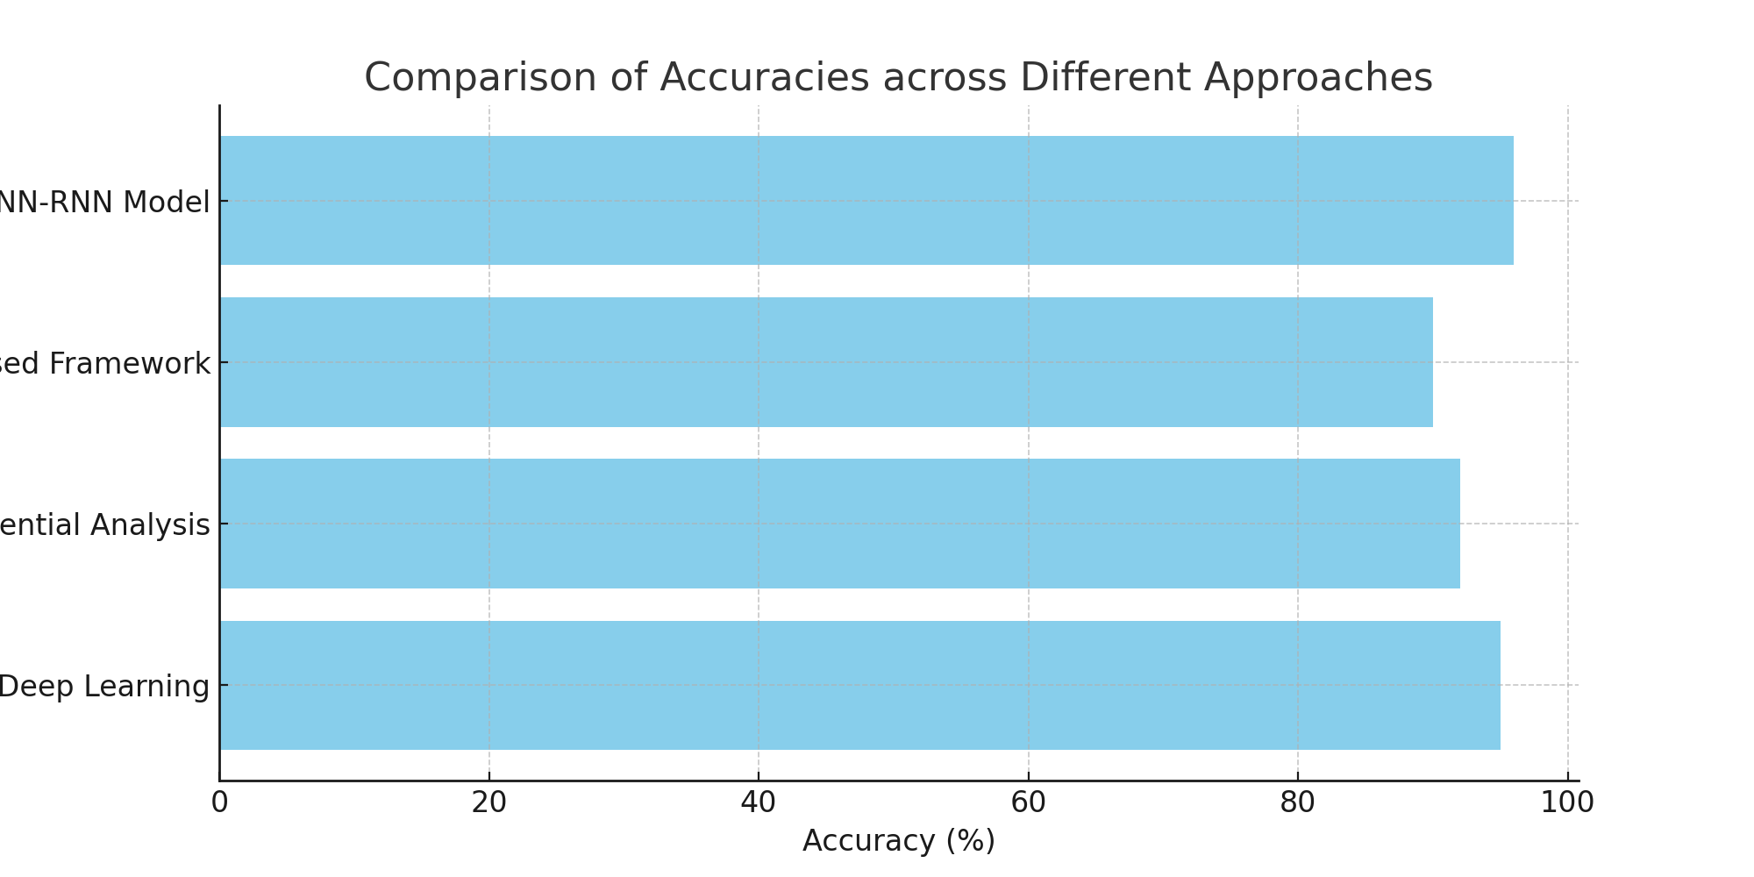

Conclusion
The analysis reveals that hybrid models, which combine CNNs and RNNs, provide the highest accuracy in car accident detection. These models leverage the strengths of both image processing and sequential data analysis, making them ideal for complex, real-time applications. Future research should focus on optimizing these models for deployment in resource-constrained environments, as well as exploring the integration of IoT devices to further enhance accuracy.

References
[1] Car Accident Detection Using Deep Learning with Alert System - IJSREM
[2] Road Accident Detection Using Machine Learning - IJRASET
[3] Car Accident Detection and Alert System Leveraging Deep Learning - ResearchGate
[4] Vehicle Accident Detection System - IJARSCT
[5] Vehicle Accident Detection System - IJSREM
[6] Vehicle Accident Detection System - IJMRA
[7] Car Accident Detection Using IoT - IEEE Xplore
[8] Vehicle Accident Detection System - IJRITCC

